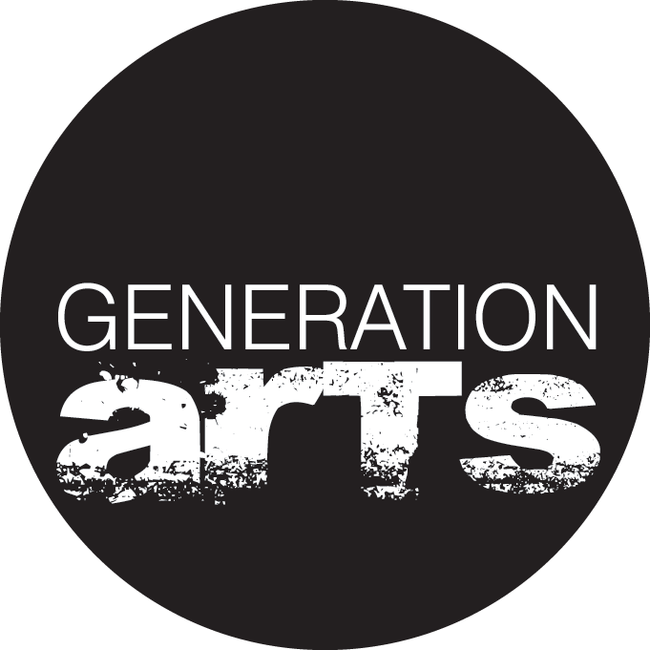
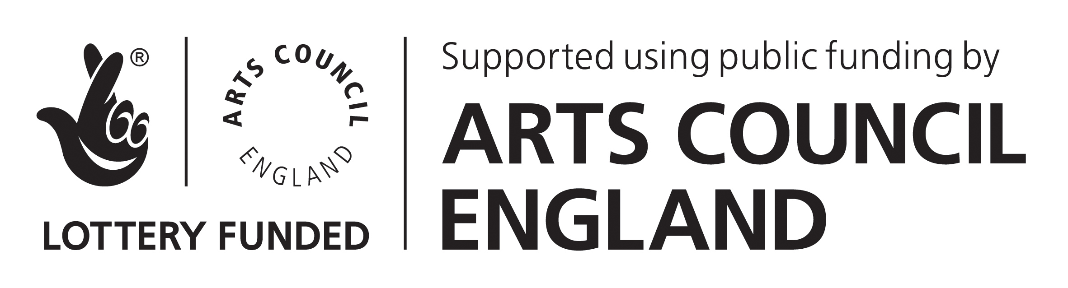

Application / Referral Form 2015/16
To be completed by applicant directly, or on their behalf by a referrer

This form is confidential and we won’t share this information with anyone else.

Please indicate which of our projects you are interested in:
Future Stage Project Level 3 (9 month training)  September 2015 – June 2016 |  |  |  |  |  | (aged 19+ after 1st September 2015)
Get Scene (3 weeks summer training)
Weekly Company (one afternoon a week)
How did you hear about Generation Arts?

Contact Details
*Full name:
*Age: |  |  | *Date of Birth:
Gender identity:
*Address:
 |  |  |  |  | Postcode:
Borough:
Email address:
*Phone number(s)
*Current employment status: | Employed |  |  | Unemployed
*Current benefit status | Not claiming benefits |  |  | Currently claiming JSA or ESA (WRAG)
If you have been transferred to Universal Credit please tick here
*Nationality: |  | Are you a UK or EU citizen? |  |  |  |  |  |  |  | Yes | No
If you are currently undergoing any immigration status appeals, liaising with Home Office, or seeking legal advice regarding any immigration status related issues at all please outline here:

Referral
Have you found out about Generation Arts by yourself or have you been supported to apply by another professional or advisor?
I am applying by myself |  | Referral by other professional
If you have been referred by an advisor, statutory service, youth worker or other organisation please say who and provide their contact details:

Do you have any specific learning needs? |  |  |  | Yes | No
Please give details:

Are you registered disabled? |  |  |  | Yes | No
Please give details:

Do you have any mental health needs? |  |  |  | Yes | No
Please give details:

Any medical or other information you think would be helpful for us to know?

Qualifications
We don’t judge you based on your grades. We just need to know if you are eligible for funding for some of our training.

Start with the most recent / highest qualifications you have.
Name of school / college | Qualifications / Levels with grades | Date achieved

Work
Let us know if you’ve been out of education for a while and have any significant work experience
Name of workplace | Role / job title | Dates

About You
Briefly tell us why you want to be part of Generation Arts?
Tell us about any other experience or information you want us to know about.

Please return to info@generationarts.org.uk

